Annual Report 2024
Voice4Thought Foundation



www.voice4thought.org

Content
Preface to the Annual Report 2

About Voice4Thought 4

2024 : Highlights and projects 5

- Voice4Thought Academy Mali 5
- V4T Archive 5
- Bon Buzz: depolarizing journalism 6
- VozPa’Colombia 7
- Tia Sauti Lab 7
- Collaboration with Bridging Humanities 8
- New website: Resultra 8
- Microgrants 8
  - Study Fund 9
  - Education Cameroon 9
  - Fund Herdsmen Bamako 10

Website and Facebook statistics 11

- Website statistics 11
- Facebook statistics 12

Organisation in 2024 12
- Board and Advisory Board 12
- Collaboration and funding 13

Looking forward to 2025 14

Preface to the Annual Report

Welcome to our year report 2024. We are happy to share our new projects and findings with you. Voice4Thought works on the crossroads between people, social change, and digital connectivity. We stand for quality knowledge production through the disciplines of arts and academics and their intersection. With the result of our own developed method, we reach out with well-informed academic, journalistic and artistic products.

In this timespan where hate speech and dis/misinformation are thriving we believe that our mission is ever so relevant. It will not have escaped your attention that at least the attention of Dutch media for Africa has almost vanished. We barely read about Sudan, where the misery of war is unprecedented. The genocide in the Middle East, the Ukraine war, and Trumpian policies compete for attention, and rightly so. However, our products inform about the Sahel and Colombia and put people who normally have not a voice in the center. Their stories help us to interpret the turbulent world around us.

Our reporters in Mali have been working hard on alternative stories that do not only portray conflict but also show the strength of people to simply live and enjoy life. The project VozPa’Colombia provides voices of exchange between indigenous and African communities. Funding for new workshops in 2025 have been accorded. And the BonBuzz projects in Chad have expanded our reporter’s network in the country enormously. The EU Tchad has accorded us a small grant to make the network of reporters in Chad a lively new journalistic endeavor to fight disinformation and polarization. We have been working on research on media and conflict in Mali that resulted in literature reviews and a new project to do research on the ground with the Mali team in 2025.

The publications of these projects and the individuals who emerge from our networks need a good platform. That is why we have decided to change our website. 2024 was for our team a moment of reflection: how can we bring our stories in an innovative way to the public arena? Mette van Dijk, a writer and artist, has been part of our team to work on this project. The result is a new organisation website, with new energy expressed in colors; and a publication website ‘resultra’ that will start to be operational from June 2025. Our reporters and relevant pieces of our own reporting will fill this website, and hopefully help their voices through journalistic, artistic and academic publication spread into a worldwide audience.

The V4TAcademy in Mali has taken a step into the Malian administration by becoming a foundation in Mali. This opens their way to other finance possibilities. As the project PGRL+ will close 31 March 2026, the search for continuity is important.

We have been able to work on these projects and to find funding for our activities with the help of our partners. In 2024 we have been collaborating on media research with Fondation Hirondelle (Switzerland), on Bon Buzz with CRASH in Chad, with the Dutch Embassy in Chad, and with GIZ-Tchad. The water mobility project in Mali has expanded and connected us to a team in Algeria, we continued our collaboration for our platform Bridging Humanities with IHE Delft and we keep our links with the University Leiden who are so kind to house our archive on their surfer. The relations with our partners are clearly based on exchanges in knowledge products, but also in developing our foundation professionally. We learned again a lot through our mistakes, but these are part of the co-creation that we strive for at every level of our actions.

We are delighted with the development of our Supervisory Board, which not only advises us but whose members are actively committed to making their networks available and providing input for project ideas. In this way, the board strengthens our organization, and we also have a form of co-creation at this organizational level. Lastly, we are proud to present our new board member: El Haje Amedou Sy. Welcome!

On behalf of the V4T team and the Board,

Mirjam de Bruijn, General Director

About Voice4Thought
Voice4Thought: dialogue and knowledge to think critically

Vision
Voice4Thought is a nonprofit foundation that offers a platform where different voices can participate in building an inclusive debate and critical knowledge on social, political and economic issues of our time. Most of these voices are actors in long-standing, often unseen, unrecognised, silenced or forgotten social and political processes of change in their countries of origin and across borders. We believe in the power of storytelling in multiple ways. Therefore, we provide them with a digital and physical space to tell their stories through academic, artistic, and journalistic expressions, workshops and outlets, and provide a space for others to rethink the world critically.

Mission
We seek to bring academia to the streets and the streets to academia: we believe in knowledge as the result of a co-creative process in which we seek for new connections and opportunities to learn in order to enable dialogue between academia, decision-makers and civil society. The reciprocal process is at the core of our aim to develop new methodologies for understanding (political) change in societies and giving a space to the unheard voices. The power of diverse Voices (V) and ways of Thinking (T) helps us to rethink our world from a critical perspective. Together we can set up new and innovative ways of creating and sharing knowledge and create an inspiring knowledge community of engaged people.

What we do
The core of Voice4Thought is our digital platform where we connect all dots. Nevertheless, we are equally engaged in on-the-ground projects and events. We host a platform for bloggers worldwide and organiseworkshops, debates and cultural events. We support voices and collectives with whom we work in writing and executing projects, such as the Voice4Thought Academy in Mali. Next to this, we have a peer-reviewed and academically recognised online publication, Bridging Humanities.

In our work we focus on the use and integration of different media and sources: text, video, photography, audio, cartoons and multimedia. We use different and new research methodologies in an experimental framework, which involves using visuals to promote an interactive fruition of our projects. With this approach, we aim to elaborate new forms of dissemination of knowledge by collaborating with cultural organisations, universities and publishing houses to start new initiatives inspired by the V4T philosophy.

ANBI Status and Chamber of Commerce
Voice4Thought Foundation is recognised by the Dutch Tax Department as a public benefit organisation. It has an ANBI status (Algemeen Nut Beogende Instelling). The RSIN fiscal number of the foundation is 856321382. We are registered with the Dutch Chamber of Commerce/Kamer van Koophandel (KvK 65930029).

More information can be found on our website: www.voice4thought.org
2024: Highlights and projects

1. Voice4Thought Academy Mali

The V4T Academy in Mali has been working with a new team in Bamako. Modibo Galy Cissé, Mamoudou Togola, Tabita Goita and Aboubacar Camera are the core of the hardworking team who have expanded our network of youth together with the teams in the 8 regions in Mali. The production of video's, documentaries, and articles have been on the rise, showing that the Academy reaches a mature stage. The search for new funding also started in 2024 as the programme PGRL+ will close its doors in March 2026. V4TAcademie Mali has become a research and artistic center and combines the two 'savoirs' in its products successfully.

V4TA and V4T are also working in different research projects together, such as on water mobility, media and polycrisis. V4TA is now also very active on TikTok and has a huge reach into the international public. The network of youth that has been built over the past 5 years is showing its strength!

2. V4T Archive

In 2024, the teams in Mali continued to upload a wide range of data, including photos, reports, text and audio interviews, video registrations of slam and theatre performances, and more to the dedicated archive site at https://v4tarchive.org. Highlights from the Archive were shared via the V4TA and V4T websites, and connected to social media.

We used a copy of the V4TA archive infrastructure to build a new and dedicated platform for the PGLR+ consortium, the CAN (in French: Centre d'Archivage Numerique, or Digital
Archiving Center). The partners involved in the consortium expressed their interest in building and maintaining a site to upload and share content related to their projects in the PGLR+ regions. While the V4TA archive focuses primarily on the content created by teams in the V4TA cercles, the new site offers dedicated space for each partner’s content, including a selection of publications by Voice4Thought. The intention is for this content to enhance the public function of Voice4Thought’s own Mali archive and the V4TA Mali website.

The domain name extension .ml (for Mali) emphasises the site’s focus on content from and by Mali: https://pglrarchives.ml. Web hosting is provided by the University of Leiden within a secure and sustainable environment. The site was built by V4T and V4TA during a workshop in January and February 2024. Further workshops were organised during 2024 and early 2025 to craft content and train the partners.

3. Bon Buzz: depolarizing journalism

In 2024 the Bon Buzz program in Chad continued with workshops in February, June, September and November. Over the course of 12 months Bon Buzz trained about 100 Chadian journalists from all over Chad. We are proud to have welcomed participants from different areas of Chad, differing in sex, ethnicity and religious backgrounds. The group diversity greatly enhanced the quality of our workshops as it allowed for a wide range of perspectives during group discussions.

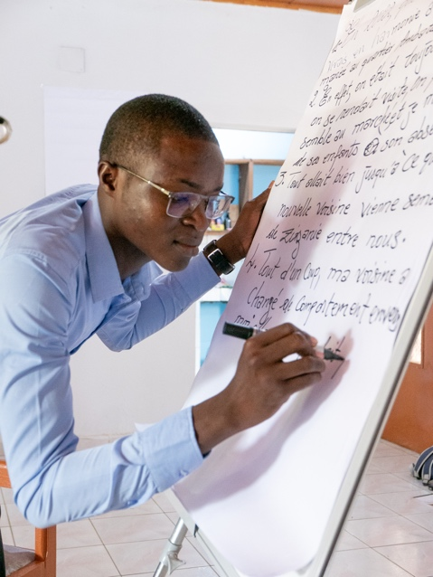
Picture: Participant of the workshop.

The first published articles are now available on the Voice4thought website and accessible in both French and English language. Participants wrote on a wide variety of subjects including farmer/herder disputes, intercultural marriage and the north/south division in Chad.
Furthermore, in collaboration with the German NGO GIZ, Bon Buzz organised a workshop on pastoralism and transhumance. Articles resulting from this workshop can be found on our website.

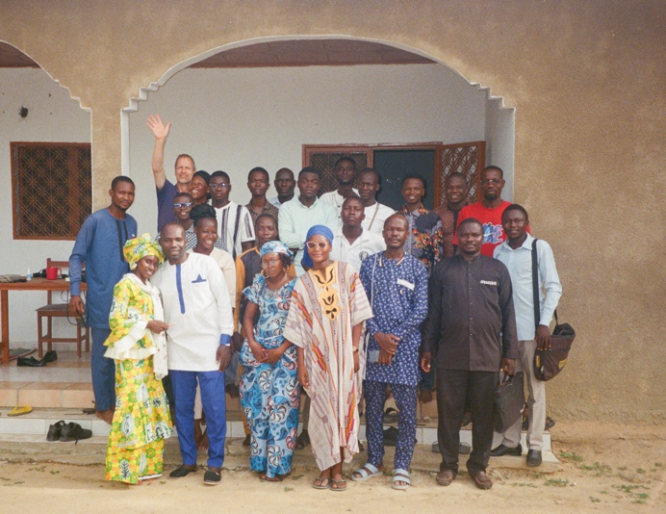
Picture: Group of Bon Buzz participants.
4. VozPa’Colombia

VozPa’Colombia has been taken its first steps to realization. By August, the project plan was finalized and the Instagram page was launched, sharing inspiring content and project updates. Fundraising started in October, and thanks to the support from private donors, we are set to bring the project to life in 2025.

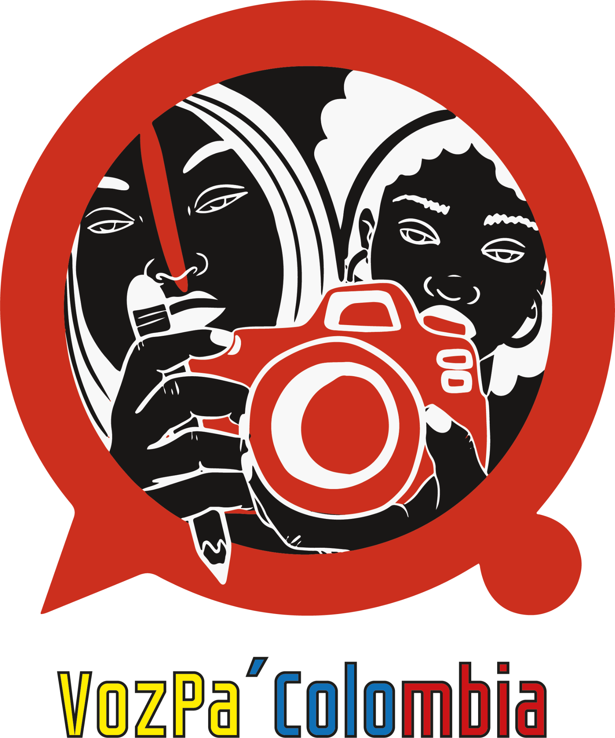

5. Tia Sauti Lab

TiaSauti@Lab “gives voice” to Swahili pocket literature, a genre rarely included in scholarly discussions, classrooms, or bookshops. It explores Swahili orature via digital content, a vodcast series featuring conversations on contemporary Muslim cultural life through a rereading of 20th-century Swahili pamphlet literatures. In August, the pilot phase was kicked off with workshops in Dar es Salaam (Tanzania) and Lamu (Kenya). In this project, V4T is a partner, working with Tanzanian publisher Mkuki na Nyota, researcher Annachiara Raia (Leiden University / African Studies Center) and a team in Lamu.
The first episode was recorded and went into production in 2024, and will be published online in 2025, with the Voice4Thought website as its main outlet outside East Africa.

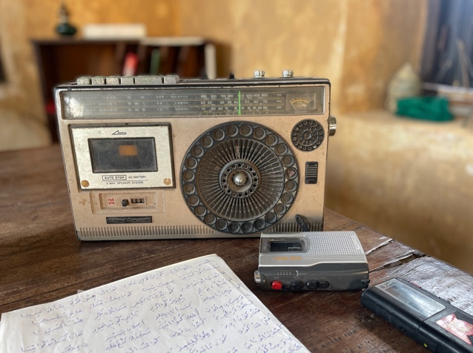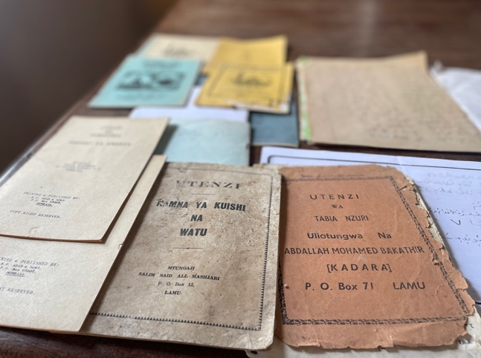
Pictures: Portable cassette player used to record Swahili poetry in Lamu from the 1970s, and Swahili booklets from the mid- to late 20th century.
6. Collaboration with Bridging Humanities

Bridging Humanities is V4T’s open access, peer reviewed, interdisciplinary, multi-area and
academic platform, that allows a working place to publish digital projects in innovative
formats. Bridging Humanities includes original research from the Humanities intended as an
open field that is connected with other disciplines in co-creation with others. In 2024 we welcomed Pelle Yntema as co-editor of the journal. He worked on the publication of Nile Pop in collaboration with IHE Delft (Institute for Water Education). Until 2024 Bridging Humanities was a publication of Brill Academic Publishers which merged with the German publishing house De Gruyter into DeGruyterBrill. This merger might have consequences for Bridging Humanities as the new publishing house is reviewing their portfolio. Currently, the Nile Pop publication is almost finished and there are no new projects yet, however we are always on the lookout for interdisciplinary social science projects to publish.

7. New website: Resultra

In late 2024 we started with the reorganization of our website because we felt it was time for a new infrastructure presenting our organisation and publications in a clearer manner. A major change will be the separation of presentation of the organisation itself (or methodology, team, projects) and the publication website ‘resultra’.

In the presentation of the organisation we make a shift towards methodology, putting at the core our way of thinking and seeing the world, as well as the competencies of the V4T members. We will present the products from our projects and network on the publication website. A creative plan for this will be written in early 2025, and funding will ultimately be sought to further develop the platform into a dynamic platform with a high level of activity. In the early months of the coming year the organisation website will be live, and thereafter the publication website.

8. Microgrants

Through microgrants, Voice4Thought supports individuals in developing themselves and building a sustainable future. This can be in the form of education, through the Study Fund or the Education Cameroon program (a specific program for schoolchildren in northwest Cameroon), but we also provide nonprofit wages for individuals to help them take a step further towards financial stability in a context of, amongst others, conflict, oppression, marginalisation. See below the fund for displaced herdsmen in Mali.

Core motive of granting the microgrant is creating the opportunity for letting their voices and stories be heard. The recipients are responsible, in co-creation with Voice4Thought, for giving this shape.

Microgrants are funded by donations.
8.1 Study Fund

The Study Fund gives out scholarships to motivated students who want to personally grow and increase their knowledge but do not have the means to realise their ambition. This year we funded another student in Cameroon, Rahama Khalid, finishing his masters degree in Environmental and Sustainable Development Engineering. We hope to expand the scholarship fund next year by finding sponsors, using previous success stories to inspire them.

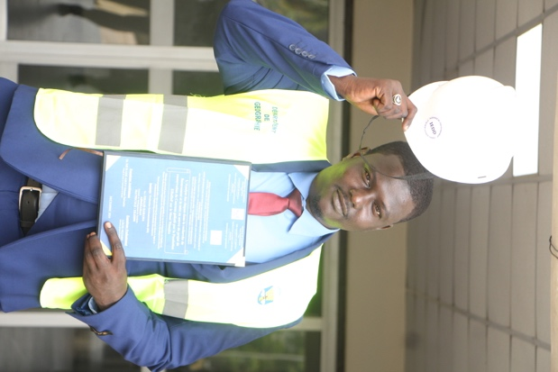
Picture: Khalid Rahama.

8.2 Education Cameroon

With the Education Cameroon project, we support young people in the English-speaking part of Cameroon who otherwise do not have the financial means to go to school. At this moment, we are monitoring 45 pupils. Most of them are based in Bamenda, some in Douala, Limbe and Baba.

The pupils were previously part of an orphanage project in the Baba region (read more about how the project came to us). Due to the conflict that broke out in Anglophone Cameroon in 2016, the orphanage was destroyed, and the children were displaced across the region. V4T managed to localize the children and maintain personal contact with them.

We are proud to announce the graduation of two of the students in December: Wongibe and Christian both graduated with a degree in Geography and town planning.

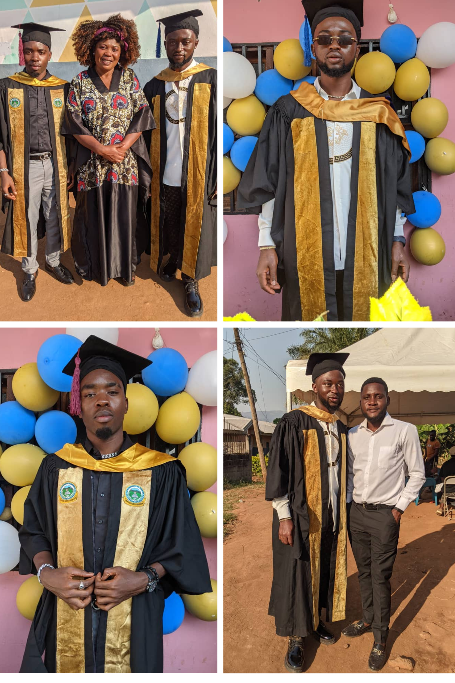
Pictures: Top left: Wongibe, guardian Madam Judith, Christian, top right: Wongibe, down left: Christian, down right: Wongibe and Lukong Godwill.

Lukong Godwill is our coordinator for the Education Cameroon project. He supervises the payments to the schools and keeps us informed about the children’s progress. Through (private) donations we have been able to support the children in their educational efforts. We paid school fees for 23 children: 12 for their secondary school in Bamenda, 6 in Douala, 4 for their university fees in Bamenda.

At the same time we are developing a project proposal with Godwill on participatory storytelling for young people in Bamenda. Since the starting of the armed conflict in 2016 in Anglophone Cameroon, the city, and especially its youth, has been greatly affected. The absence of reliable information and the traumatic experiences of war are directly related to the ability of residents to participate in the peace process in a meaningful way. We aim to create a safe space for critical and creative thinking. This will allow young people to share their experiences of isolation and come up with new perspectives and ways of thinking about the past and future. The aims of this project will be threefold: To offer young residents in Bamenda new tools to tell their stories, providing a platform for unheard voices, and creating meaningful encounters in a polarised society.
Funding for the project will be sought in 2025.

8.3 Fund displaced Herdsmen Bamako

Since 2015, central Mali has become unsafe for its population. Many people are fleeing
violence from various armed groups: the army, the Russians (Wagner group), the Dozo (a
militia composed of traditional hunters), and groups of Jihadists. There are also small other
armed groups defending their own villages.
The Fulani pastoralists are in between all the groups. They live in the Sahel region and are
known there as specialists in raising livestock (goats, cattle, camels), developing a semi-
nomadic lifestyle. The Fulani herdsmen are considered an important pillar of Jihad. Some of
these nomads have joined the Jihadist armed groups in the region. With the image of Fulani
as Jihadist, and terrorist, they are perceived as violent. Consequently, they are targeted by
all the other armed front groups mentioned above. However, very many Fulani nomads are
not affiliated with one camp and therefore live in a situation of constant insecurity. As a
result, many Fulani flee the area, often arriving in Bamako via dangerous routes.
To help a group of herdsmen and cattle traders in Bamako a fund has been
established for them. The fund works like a loan, without profit motive, which will be repaid
by them. However, equally important is the aim of this project to give the shepherds and
cattle traders a voice in the context of the conflicts in their country. We aim to record their
stories.

In 2024, it has been difficult for the herdsmen to keep their heads above water. Livestock markets were closed due to attacks in the city and also because of accusations against the herdsmen. Besides, it is difficult for the average man/woman to get by. Despite setbacks, the herdsmen are trying to maintain the fund and half of the wages have now been repaid. During a follow-up visit to the herdsmen in Bamako, discussions will be held on how to continue the fund.

Website and Facebook statistics

1. Website statistics

Voice4thought.org

In 2024, the Voice4Thought.org website got a total of 6300 visitors. This is a small increase from the year before (900). Organic search accounted for 45% of this amount; 37% reached the website directly (by typing in the URL); 12.9% was referred from another website (of which the majority arrived on a single day: 26 October 2024), and 4% from social media.

About half of the visitors used English as their browser language, followed by French (almost 25%), Dutch (8%), Spanish, Chinese, German and Italian. The top countries of visitor origin were USA (23%), Netherlands (12%), Chad (7,5%), Mali (6,5%), France (5,8%), followed by China, Cameroon, Germany, Belgium and UK. Important cities in the statistics include N’djamena and Bamako.

V4tacademie.org

That same year, the V4TA website in Mali welcomed 1633 visitors, slightly less than in 2023. Slightly over one-third of visitors to the site (665) were from Mali, and from those, a large majority was located in Bamako. 950 visitors had their browser language set to French, and about 550 to English (the website language is French only).
Despite frequent publications of articles and blog posts during 2024, the primary engagement of the audiences in Mali was through social media rather than the website.
2. Facebook statistics

During 2024, the Voice4Thought Facebook page reached 3100 visitors; an increase of 66% compared to 2023. Current top followers are from Chad (26%), Netherlands (21%), Mali (10.6%) and Cameroon (6,1%).

Organisation in 2024

The Voice4Thought team consists of an enthusiastic group of people who aim to connect different worlds, in collaboration with others. The organisation serves as a unifying platform where individuals, each driven by their own motivations, develop and promote their eclectic projects. In 2024, the team consisted of:

Vera Bakker photographer, editor & researcher
Mirjam de Bruijn general director & researcher
Maartje van den Eijnden finance & organisation
Thomas Gesthuizen web & IT, researcher
Laurens Nijzink, journalist podcast specialist & researcher
Jasmijn Peeters researcher
Sjoerd Sijsma audiovisual specialist & artist
Catherina Wilson researcher
Pelle Yntema researcher

Mette van Dijk temporarily member website creation

2. Board and Advisory Board

We were very happy to welcome our new supervisory board member El Haje Amedou Sy!

And we are delighted to already announce that Walter Gam Nkwi will join the Advisory Board as of June 1st2025.

Supervisory Board

Maarten Mous
Daphne Pit
Affoh Guenneguez
Fiona Dragstra
El Haje Amedou Sy

Advisory Board

Balt Leenman
Kitty Zijlmans
Freek Stoopendaal

Our Supervisory Board and Board of Advisors are not remunerated for their contributions to the organisation.

3. Collaboration and funding

Active Partnerships in 2024

Bridging Humanities, the Netherlands
Chad+, Chad
Coup d’Afrique Slam de Poésie (CASP), Cameroon/Chad
CRASH, Chad
Eyeses, the Netherlands
Five Stars, Chad
ICCO/CORDAID, the Netherlands/Mali
Leiden Global, the Netherlands
Ndjam s'enflamme en slam, Chad
Oxfam, the Netherlands/Mali
Slameroun, Cameroon
SNV, the Netherlands/Mali

Funding partners and donors in 2024

Dutch Embassy, Bamako
Fondation Hirondelle, Switzerland
IHE Delft, Netherlands
Oslomet University, Norway
European Union, Chad
Ministerie van Buitenlandse Zaken, the Netherlands
Leiden University, the Netherlands
University of Wisconsin, United States
Stichting Operatie Periscoop, Netherlands
We have also received private donations for the Cameroon Education program and the Study Fund.

Looking forward to 2025

- We are looking forward to develop and launch our new organisation and publication website. An important new step for our organisation.
- In February 2025 Bon Buzz will host a conference in CEFOD in N’Djamena for participants, journalists, influencers and bloggers.
- Continuing the success of Bon Buzz, Bon Buzz III will be developed next year in Chad.
- We are excited to start with Voz’Pa Colombia on the ground. Preparations are in full swing!
- Together with GIZ and Hirondelle we will extend our projects to the Sahel.
- We are excited to have an intern join the archive team of the African Hip Hop Archive project. A wealth of musical media have been stored and we can’t wait to preserve them in an online archive, and share parts with a larger audience.

